Name: Gowtham Paluri

ID: 700741225

Video Link: <https://drive.google.com/file/d/1JvjXiRYDv1pVszbBMwaVuxGCOqDKqVPB/view?usp=share_link>

Github link: <https://github.com/gowtham8666/Machine-Learning-Assignments/blob/main/Machine%20learning%20Assignment%202.py>

Q1. Use a python code to display the following star pattern using the for loop

*

* *

* * *

* * * *

* * * * *

* * * *

* * *

* *

*

🡺The first loop for i in range(0, rows) prints out the top half of the pyramid, and the second loop for i in range(rows, 0, -1) prints out the bottom half of the pyramid.

The inner loops for i in range(0, i + 1) and for j in range(0, i - 1) control the number of asterisks to be printed on each row. The end=' ' argument in the print() statement is used to specify that a space should be printed after each asterisk

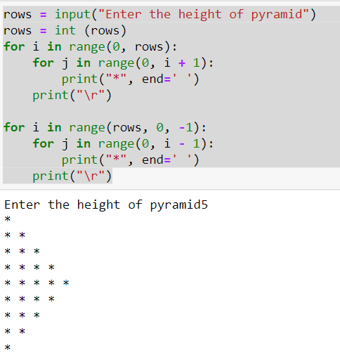

Q2. Use looping to output the elements from a provided list present at odd indexes. my_list = [10, 20, 30, 40, 50, 60, 70, 80, 90, 100]?

🡺The loop for i in range(1, len(my_list), 2) iterates over the indices of the elements in the list, starting from 1 (the first odd index), and increments the index by 2 on each iteration.

Q3. Write a code that appends the type of elements from a given list.

Input

x = [23, ‘Python’, 23.98]

Expected output

[23, 'Python', 23.98]

[<class 'int'>, <class 'str'>, <class 'float'>]

🡺The loop for i in range(len(s)) iterates over the indices of the elements in the list s, and the x.append(type(s[i])) statement is used to append the data type of the current element in s to the list x.

Q4. Write a function that takes a list and returns a new list with unique items of the first list. Sample List: [1,2,3,3,3,3,4,5] Unique List: [1, 2, 3, 4, 5]

🡺The code defines a function unique_list that takes in a list l as input. The function creates an empty list x.

Then, it iterates over the elements of the input list l. For each element a in l, it checks if it is already in the list x. If a is not in x, it appends a to x.

Finally, the function returns the unique list x that contains all unique elements from the input list l.

The code then calls the function unique_list with the list [1, 2, 3, 3, 3, 3, 4, 5] as an argument and prints the result, which is [1, 2, 3, 4, 5].

Q5. Write a function that accepts a string and calculate the number of upper-case letters and lower-case

letters.

Input String: 'The quick Brow Fox'

Expected Output:

No. of Upper-case characters: 3

No. of Lower-case Characters: 12

🡺The code defines a function up_low that takes in a string string as input. The function initializes two variables uppers and lowers to 0, which will be used to count the number of uppercase and lowercase characters in the input string.

Then, it iterates over the characters in the input string. For each character char in string, it checks if char is a lowercase letter using the method islower(). If char is a lowercase letter, it increments the lowers count by 1. If char is not a lowercase letter, it checks if char is an uppercase letter using the method isupper(). If char is an uppercase letter, it increments the uppers count by 1.

Finally, the function returns a tuple of the count of uppercase characters (uppers) and the count of lowercase characters (lowers).

